19.30: a)
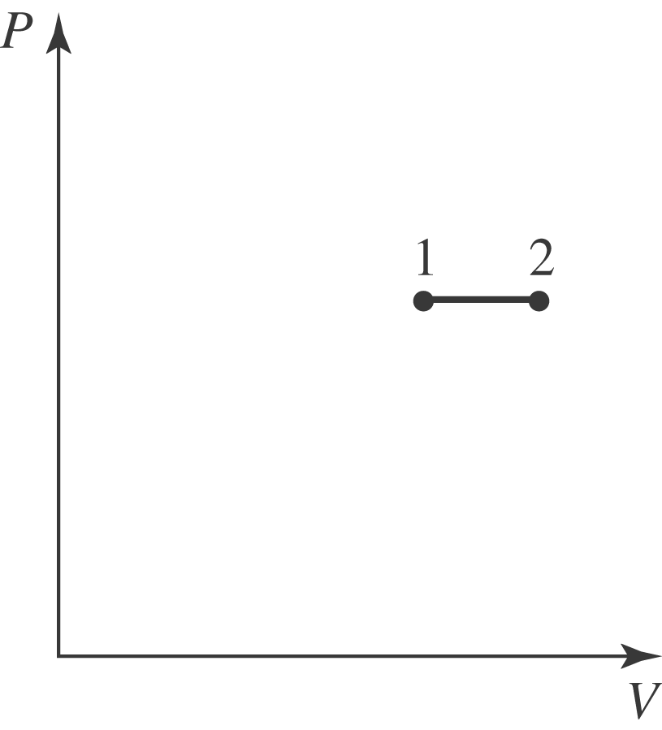
- 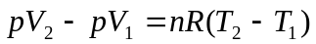

- The work is done on the piston.
- Since Eq. (19.13) holds for any process,

- Either to three significant figures.
- The lower pressure would mean a correspondingly larger volume, and the net result would be that the work done would be the same as that found in part (b).

